DAD’S DAILY JOURNAL

WORLD’S BEST DAD

THE DAD CHECKLIST:

MY DAD IS:

SUPERHERO:

HANDSOME:

MARVELLOUS:

EXCITING:

FUNNY:

LOVABLE:

COURAGEOUS:

ME WITH MY SUPER DADDY: MY SUPER HERO: THE PROTECTIVE ONE:THE MARVELLOUS ONE……… CARING:

THE FIRST AND MOST IMPORTANT PERSON IN A FAMILY IS A FATHER………. STRONG:

HE WORKS HARD AND BECAUSE OF HIS EFFORTS ONLY A FAMILY IS ABLE TO BEST:

SURVIVE.FATHER’S HAVE GREAT RESPONSIBILITY.A FATHER FULFILLS EVERY BRILLIANT:

WISH OF THEIR FAMILY.BEING A FATHER IS NOT AN EASY TASK SO WE SHOULD ALWAYS RESPECT THEM…………….

**THE SCOOP : FATHERS DAY EDITION**

WRITTEN BY:

MY DAD IS ALWAYS BEST BECAUSE……

X R D F U I E L C F C R E

**FATHER’S DAY WORD SEARCH**

W B L A S T R O P S N D K

FIND THESE WORDS RELATED TO FATHERS DAY E O D S A Z F X C E B A M

G N M P O I U T C R E D T

ATHLETIC FATHER R B R A V E H I O O M D E

TIE S I D K Y J T B S S H Y L

DAD FOOTBALL H T I Q N E F A P L L Y L

S A R S A L G R E R O O G A

ESPN FUNNY G V S H C K E L S N P O B

F R T S F I S H I N G W T

FISHING GOLF U A C O S N S T E D E O O

N S T K O D A L A D U R O

FUNNY KIND N N R H W B E D U I M G F

Y O T I E T I N C T W N U

BRAVE SPORTS A F U S R R H W E S P N W

O T E N N I S T I U S E R

DADDY TENNIS

NEWS TODAY

WINNER WORLDS

BEST DAD

World’s best dad

THIS CERTIFICATE IS AWARDED TO

GIVEN ON: GIVEN BY:

HAPPY FATHERS DAY

ONLY A MAN CAN BE A FATHER BUT IT TAKES SOMEONE

SPECIAL TO BE

DAD

ANY ONE CAN BE A FATHER BUT IT TAKES A SPECIAL PERSON TO BE A DAD

I AM FEELING LUCKY

GOOGLE SEARCH

WORLD’S BEST DAD

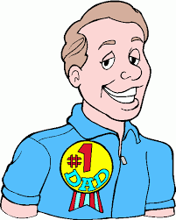 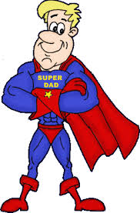 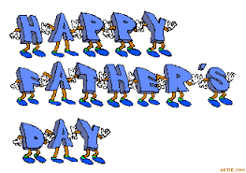

A VERY HAPPY FATHERS DAY TO U MY

LOLLIPOP